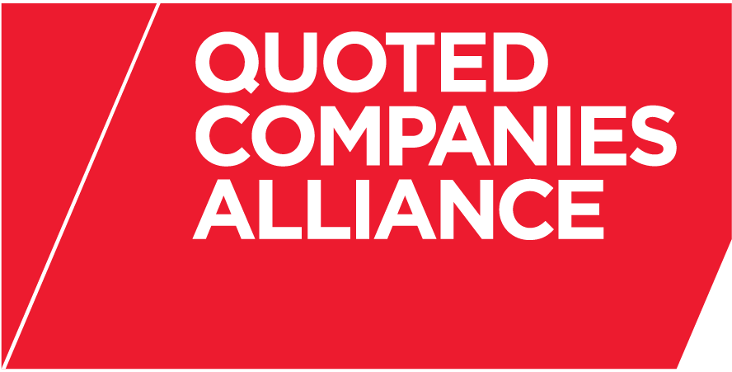

THE QUOTED COMPANIES ALLIANCE
CORPORATE GOVERNANCE EXPERT GROUP
PROPOSED MEETING DATES FOR 2014 (REVISED)

Time: 4pm (unless otherwise advised)

Venue: To be Advised

Tuesday 14 January 2014

Tuesday 25 February 2014

Tuesday 8 April 2014

Tuesday 20 May 2014

Tuesday 8 July 2014

Monday 15 September 2014

Monday 20 October 2014

Tuesday 25 November 2014

